
Lab Report 02 & 03
Data Communication & Computer Networks


Submitted To:
Engineer Shehzad Malik
Submitted By:
Sumama Rahim
F24BSCS039
BS CS (F24-A-Morning)
Date: 10/23/2025
LAB REPORT – 02 and 03
Cisco Packet Tracer – Basic Topology and Static Routing

Problem:
Make 2 router topology with 2 PCs and ping it and do network advertised missing IPs.
Solution:
Required Resources:
- 2 PCs
- 2 Routers
- Serial 0/0 interface
- FastEthernet 0/0 interface
Topology
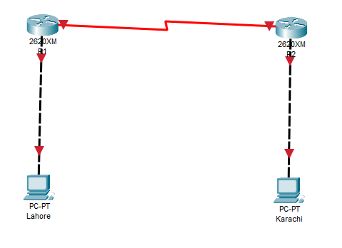
NOTE:
Addresses:
Network 1 (Router 1 and Router 2): S 0/0 1.1.1.1 and 1.1.1.2 (Via serial DCE cable)
Network 2 (Router 1 and PC1): F 0/0 2.1.1.1 and 2.1.1.2 (Via copper cross over cable)
Network 3 (Router 2 and PC2): F 0/0 3.1.1.1 and 3.1.1.1 (Via copper cross over cable)

Hardware Setup:
To enter serial interface, first we need to switch OFF of all routers and insert WIC-2T card in it and then switch ON.
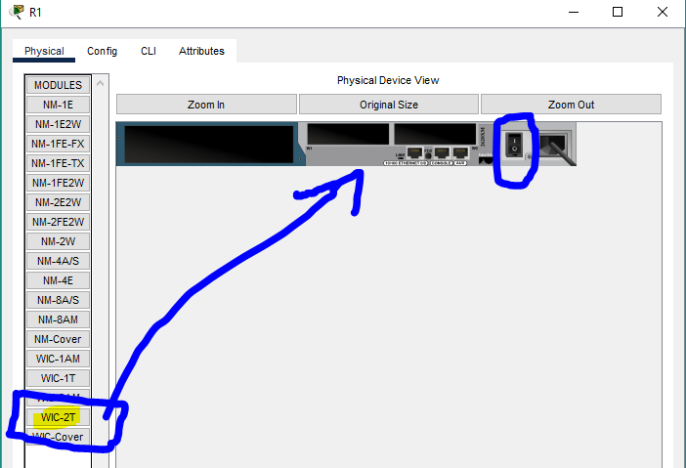

It should be inserted like this
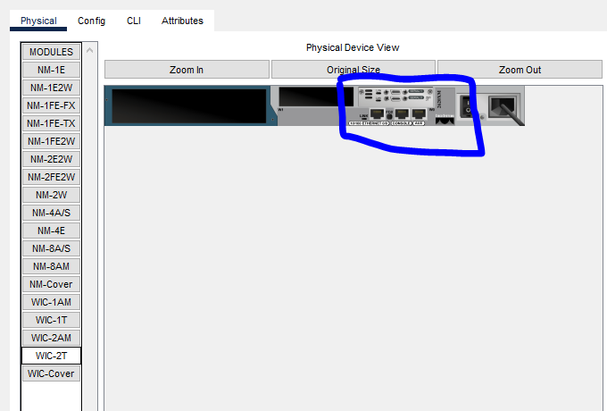

Task 1: Changing Hostnames for both routers to R1 and R2
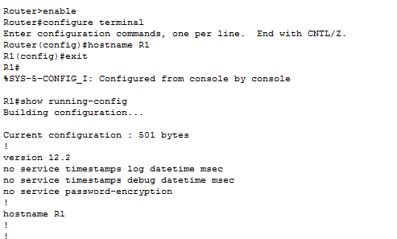

Task 2: Setting up IP addresses

For R1 (Serial 0/0 and Fast 0/0)
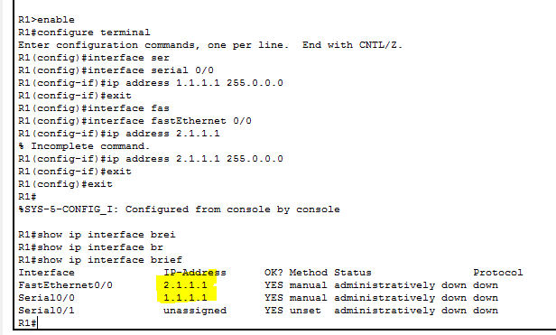

For R2 (Serial 0/0 and Fast 0/0)
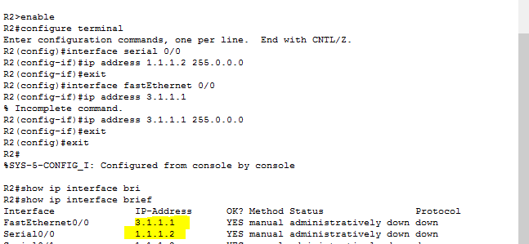

IP and Gateway for PC1 (Fast 0)
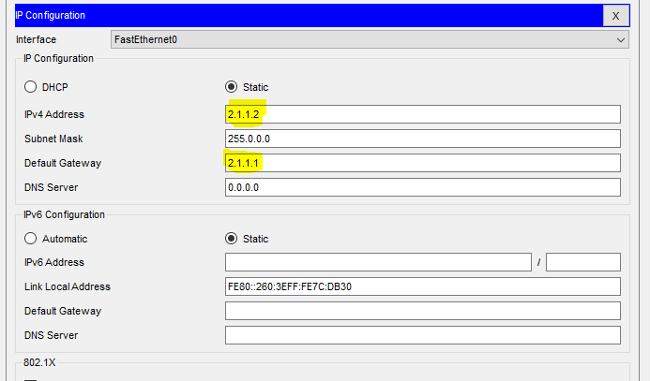

IP and Gateway for PC2 (Fast 0)
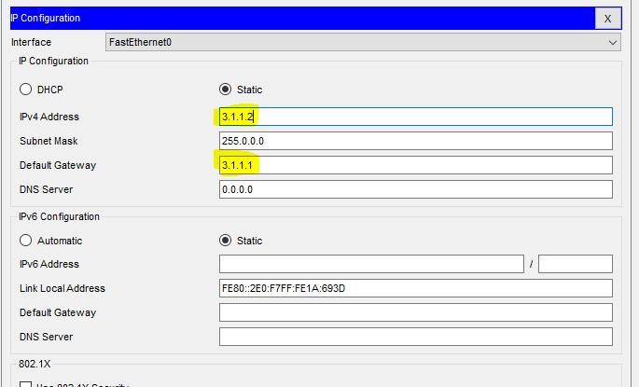

NOTE: By default, interfaces are shutdown, so we need to up it.
For R1, S 0/0
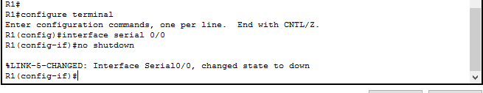
Now checking

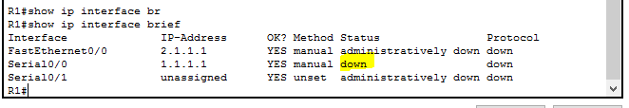

For R2, S 0/0

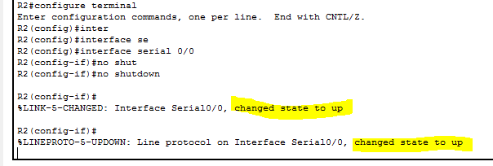

Now both routers (S 0/0) are up.
R1

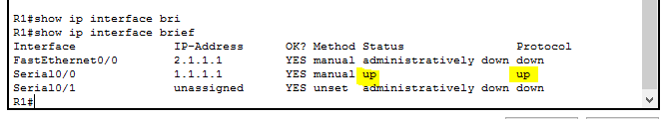
R2
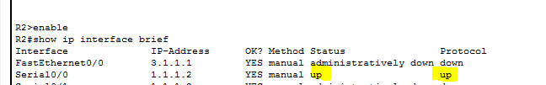

We can see, now the router links are green, which means it is configured correctly.
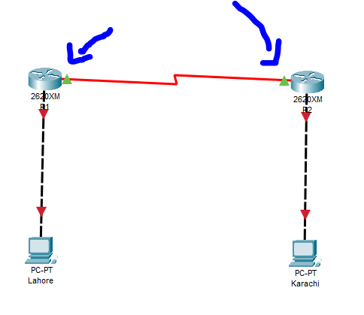
Let’s verify by pinging R1 on R2 and R2 on R1
Pinging R1 on R2 (and self)

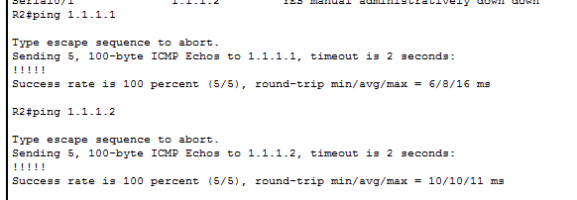

Pinging R2 on R1 (and self)
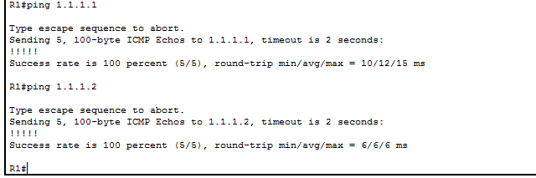

Now let’s up the both FastEthernet 0/0 to make sure the smooth connection.
On R1
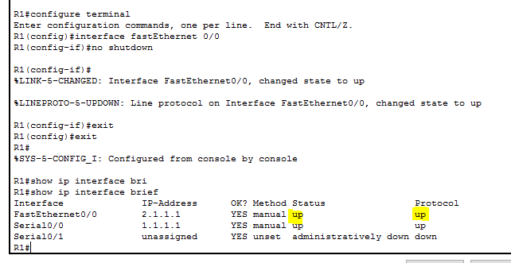
We can see the link is up so it is green now.
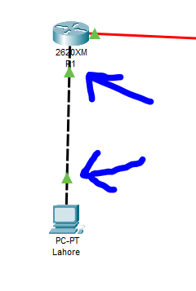
On R2
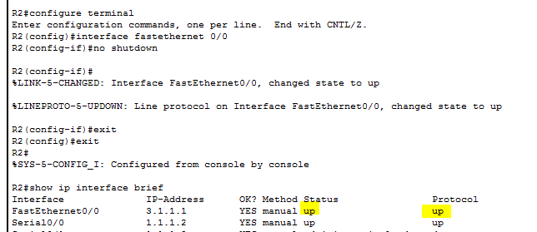

Link is up and it can be indicated by green signals like following.
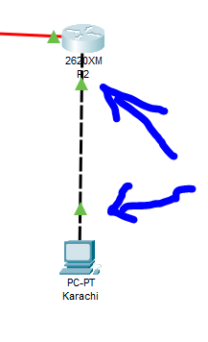
Now let’s verify the connection by ping all devices from each device. But before it we need to fix some missing networks on R1 and R2.

Advertising missing networks
On R1
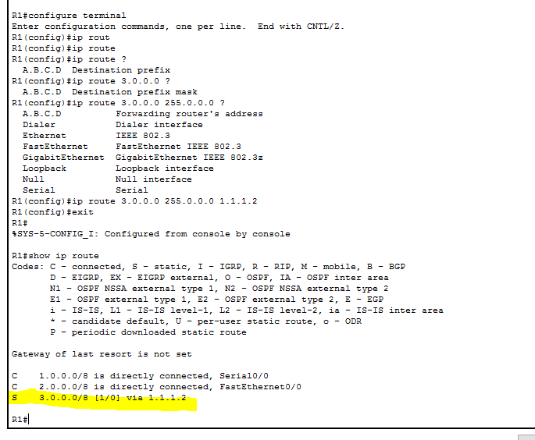

On R2

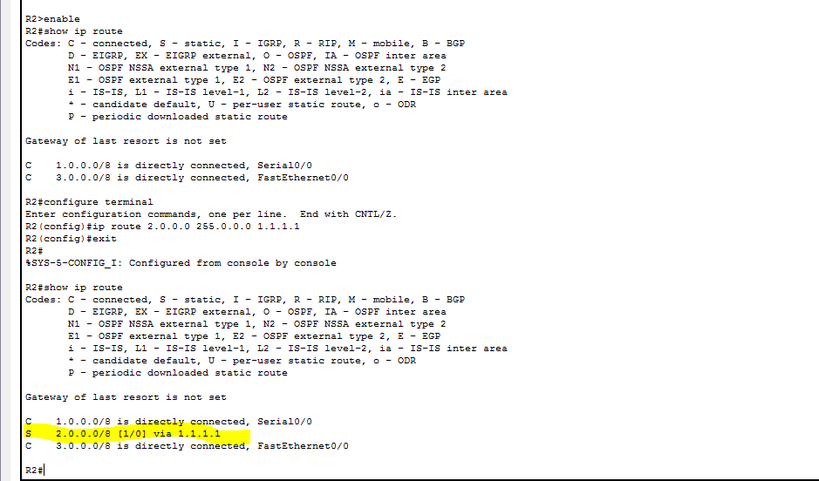

Pinging R2, PC1, PC2 on R1
Network 1.0.0.0
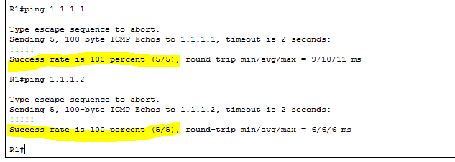
Network 2.0.0.0
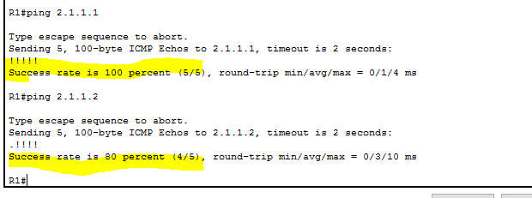
Network 3.0.0.0
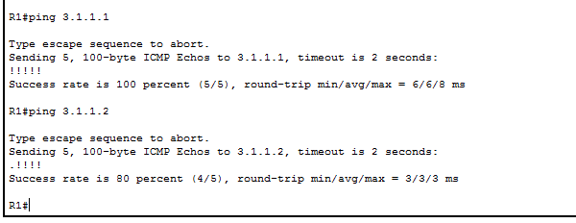

Pinging R1, PC1, PC2 on R2
Network 1.0.0.0
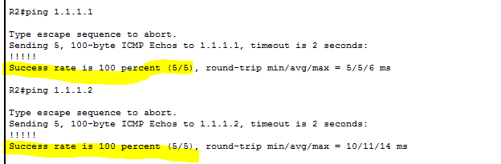
Network 2.0.0.0
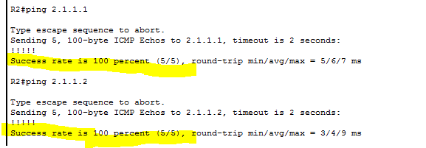
Network 3.0.0.0
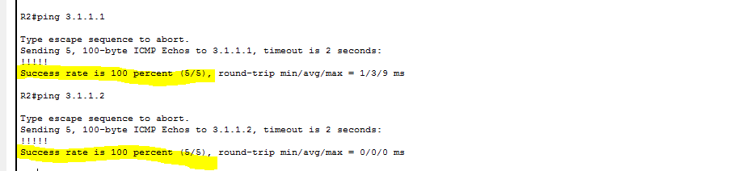

Pinging R1, PC2, R2 on PC1
Network 1.0.0.0
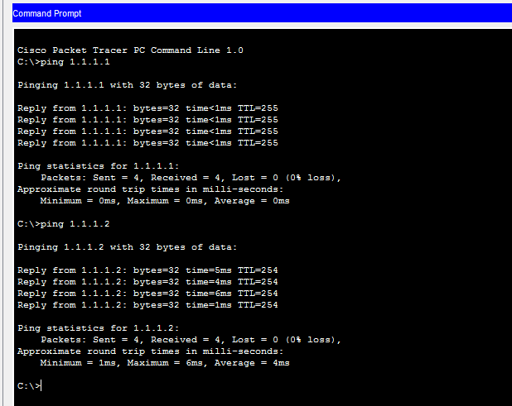

Network 2.0.0.0

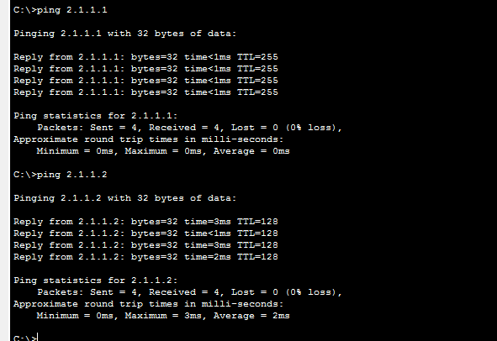

Network 3.0.0.0

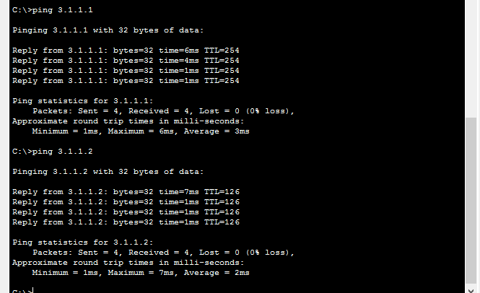

Pinging R2, PC1, R1 on PC2
Network 1.0.0.0
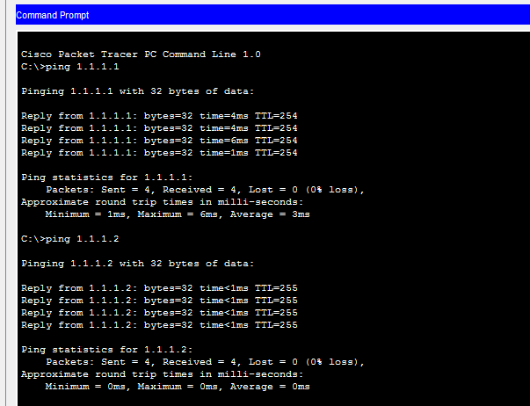

Network 2.0.0.0

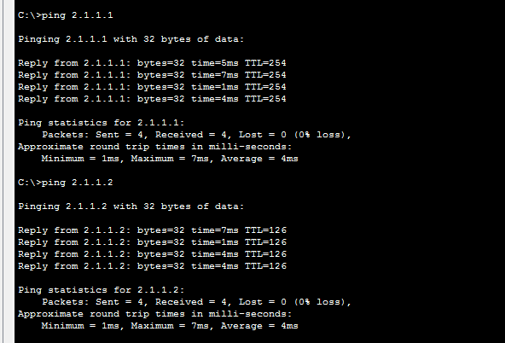

Network 3.0.0.0

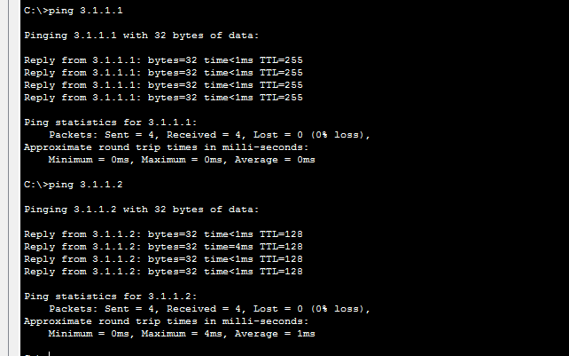

Finally, we ping all devices from each device and successfully we have communicated with each other.
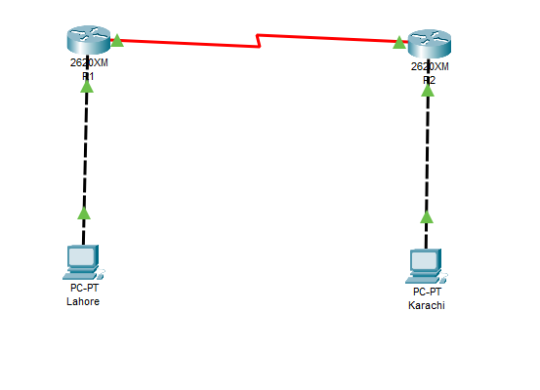
Here we noticed that each link is up and signaling as green which means they are connected successfully. Now each device can communicate with others smoothly which is verified by pinging each one from all.

The End

